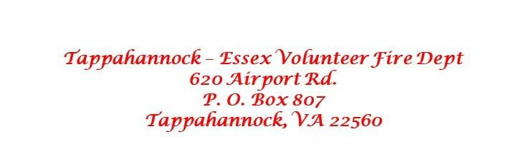

BANQUET HALL RENTAL APPROVAL FOR
TEVFD MEMBERS, FIRST RESPONDERS AND COUNTY / TOWN ADMINISTRATORS

The Officers and Board of Directors of Tappahannock-Essex Volunteer Fire Dept. approve the rental of the banquet hall for _____________________________________
on ________________________________ for _____________________________________.
To secure your date, please submit your signed contract along with this signed letter and your deposit as soon as possible.
The terms of the contract apply to all who rent the facility.

___________________________ ____________________________
Signature of Applicant Signature of TEVFD Officer

Date ____________________ Date ______________________

**Take this letter to the next monthly TEVFD officers meeting (first Monday of each month at 6:30 pm at Station 1 on Airport Dr.) for approval. Must be signed by an Officer of TEVFD and submitted to the facility administrator at least 2 weeks prior to your event.

